What is Breast Cancer?

Did you know that 1 in 8 women will be diagnosed with breast cancer in her lifetime?

Cancer grows when a cell’s DNA is damaged, but why or how is still unknown. It could be genetic, environmental, or both.

Who is at risk for breast cancer?
- Women are 100x’s more likely to get breast cancer then men
- Caucasian women
- If someone in your family has been diagnosed, your chance increases
- Mutations in certain genes like BRCA1 and BRCA2
- Having dense breast tissue
- Early menstruation (before 12) or late menopause (after 55)

AVOIDABLE RISK FACTORS
- Sedentary Lifestyle
- Alcohol Consumption
- Combined hormone replacement therapy
- Poor diet high in fat
- Being overweight or obese
- Radiation to the chest
- Smoking

Signs and Symptoms:

When breast cancer is detected early, the 5 year survival rate is 99%.

What can be done for early detection?
- Monthly breast self-exams
- Scheduling yearly clinical exams
- Mammograms starting at age 40, or earlier if there is family history
- Make healthy living a priority!

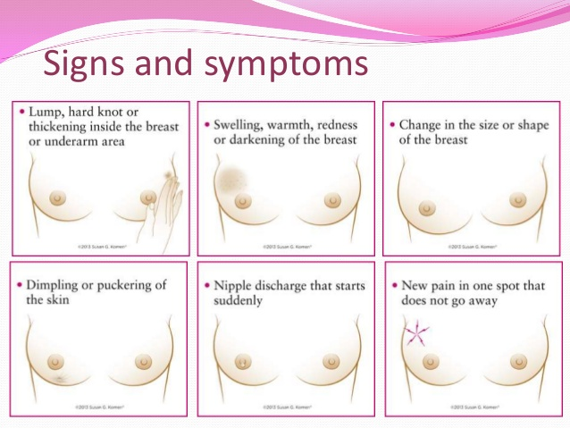

What to Look For During Exams:
- A change in how the breast or nipple feels
- A change in breast or nipple appearance
- Any nipple discharge

Treatments:

The goal is to improve treatment and recovery.

In general, there are 5 treatment
options:
- Surgery – removal of tumor and nearby margins
- Radiation - high energy waves used to
- Hormone Therapy - drugs that destroy cancer cells by cutting off the supply of hormones
- Chemotherapy – a treatment method that uses a combination of drugs to destroy
- Targeted Therapy – attacks specific breast cancer cells without harming normal cells

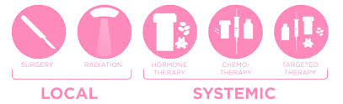

- Breast cancer typically has no symptoms when the tumor is small and most easily treated.

- The most common sign of breast cancer is a painless lump.

- There is no sure way to prevent breast cancer but there are ways to lower your risk.

- A biopsy is the only way to know for sure if its cancer.

- If your doctor suspects you may have cancer, certain tests can be ordered including chest x-ray, CT scan, bone scan, PET scan, or MRI scan.

- Breast cancer occurs almost entirely in women but CAN occur in men too.

Mammograms should be covered under insurance.

Most breast cancers are found on screening mammograms, before they can even be felt and before symptoms develop.

For information about free or low cost mammogram screening programs, call National Cancer Institute at
1(800)422-6237 or visit the American Cancer Society at Cancer.org.

What You Need to Know About
BREAST CANCER

